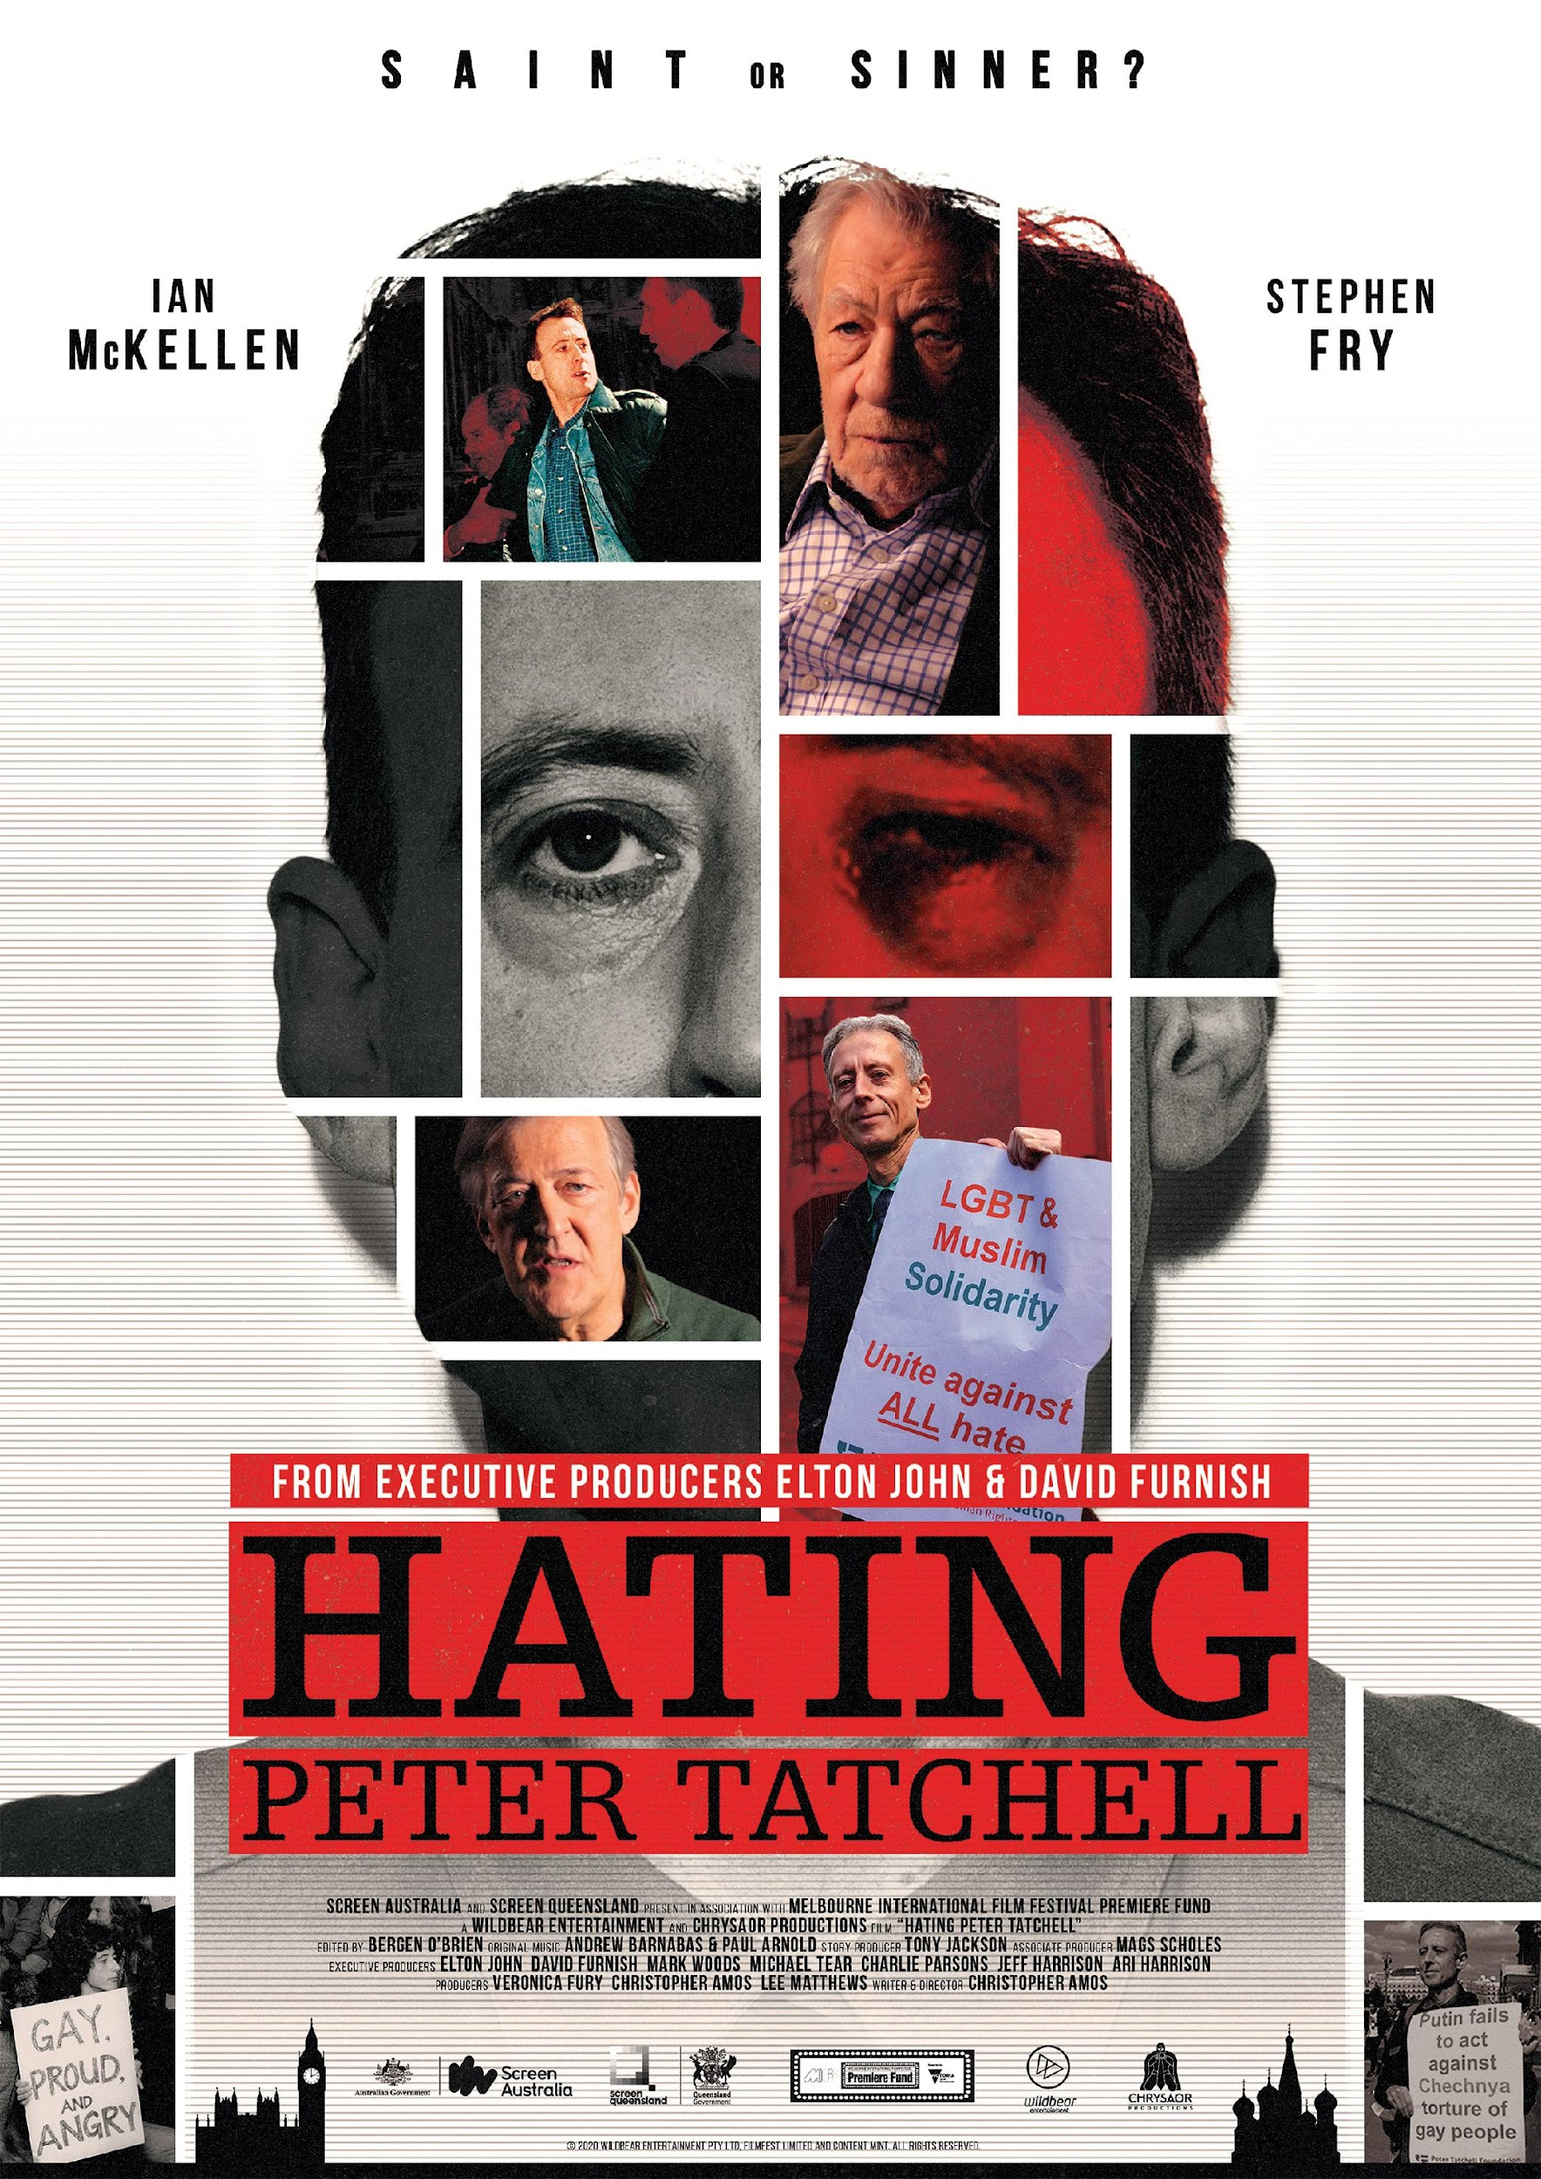
CONTENTS

CONTACT DETAILS 3
TECHNICAL INFORMATION 4
SYNOPSIS 5
DIRECTOR’S STATEMENT 8
PRODUCER’S STATEMENT 9
KEY CREATIVE CREDITS 10
BIOGRAPHIES 11
INTERVIEWEES 16
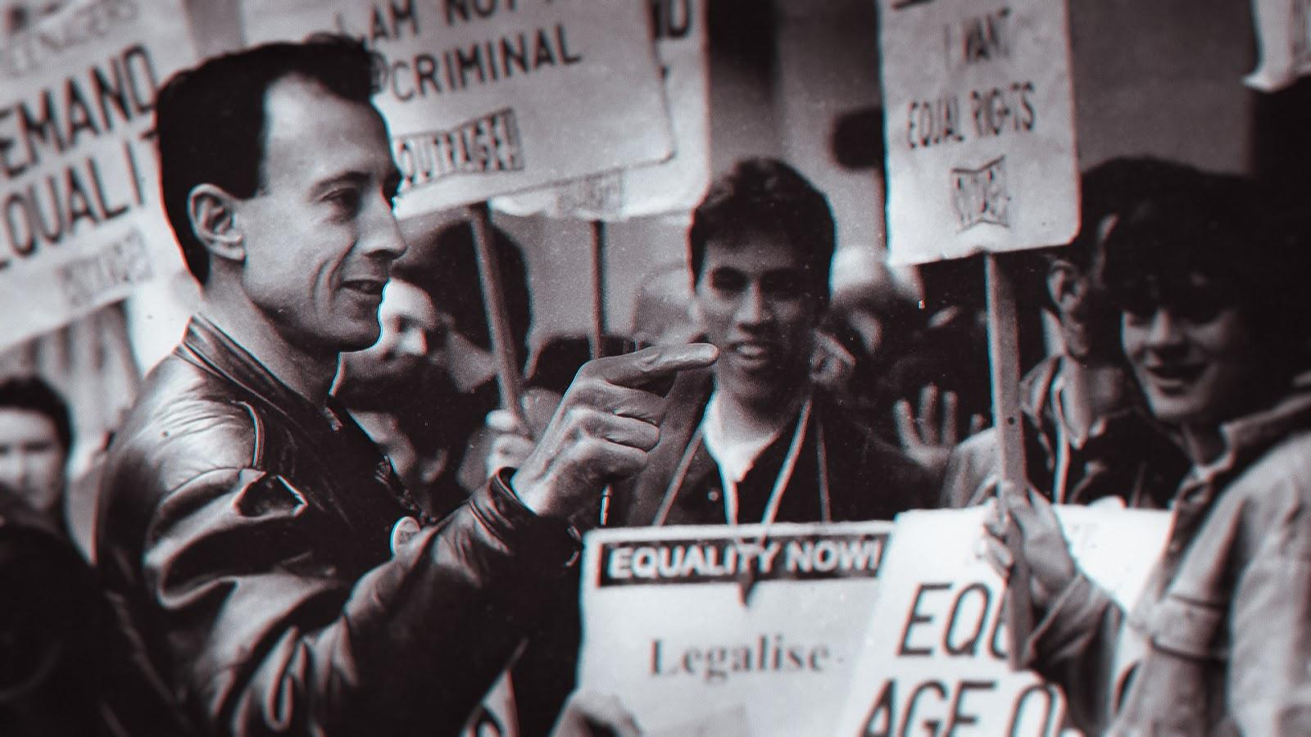
FINAL END CREDITS 17
PRODUCTION CONTACT DETAILS

WILDBEAR ENTERTAINMENT
Address: PO Box 6160, Woolloongabba
Queensland 4102 AUSTRALIA
Phone: +61 7 3891 7779
Website: www.wildbear.tv
VERONICA FURY - PRODUCER
Address: PO Box 6160, Woolloongabba
Queensland 4102 AUSTRALIA
Phone: +61 7 3891 7779
Email: info@wildbear.tv

DISTRIBUTION DETAILS
AUSTRALIA AND NEW ZEALAND
Umbrella Entertainment
Address: Unit 13, 79 - 83 High Street Kew
Victoria 3101 AUSTRALIA
Phone: +61 3 9020 5130
Email: ari@umbrellaent.com.au
Website: www.umbrellaentfilms.com.au
REST OF WORLD
WildBear Entertainment
Address: PO Box 6160, Woolloongabba
Queensland 4102 AUSTRALIA
Phone: +61 7 3891 7779
Email: info@wildbear.tv

TECHNICAL INFORMATION
Production Format
1:85:1 2K Flat (1998 x 1080)

Frame Rate
25fps

Release Format
2k HD ProRes, DCP

Sound Configuration
DCP 5.1 2.0 Stereo
ProRes 5.1 surround 2.0 Stereo Mix

Duration
92 Minutes

Date of Production
2020

Date of Release
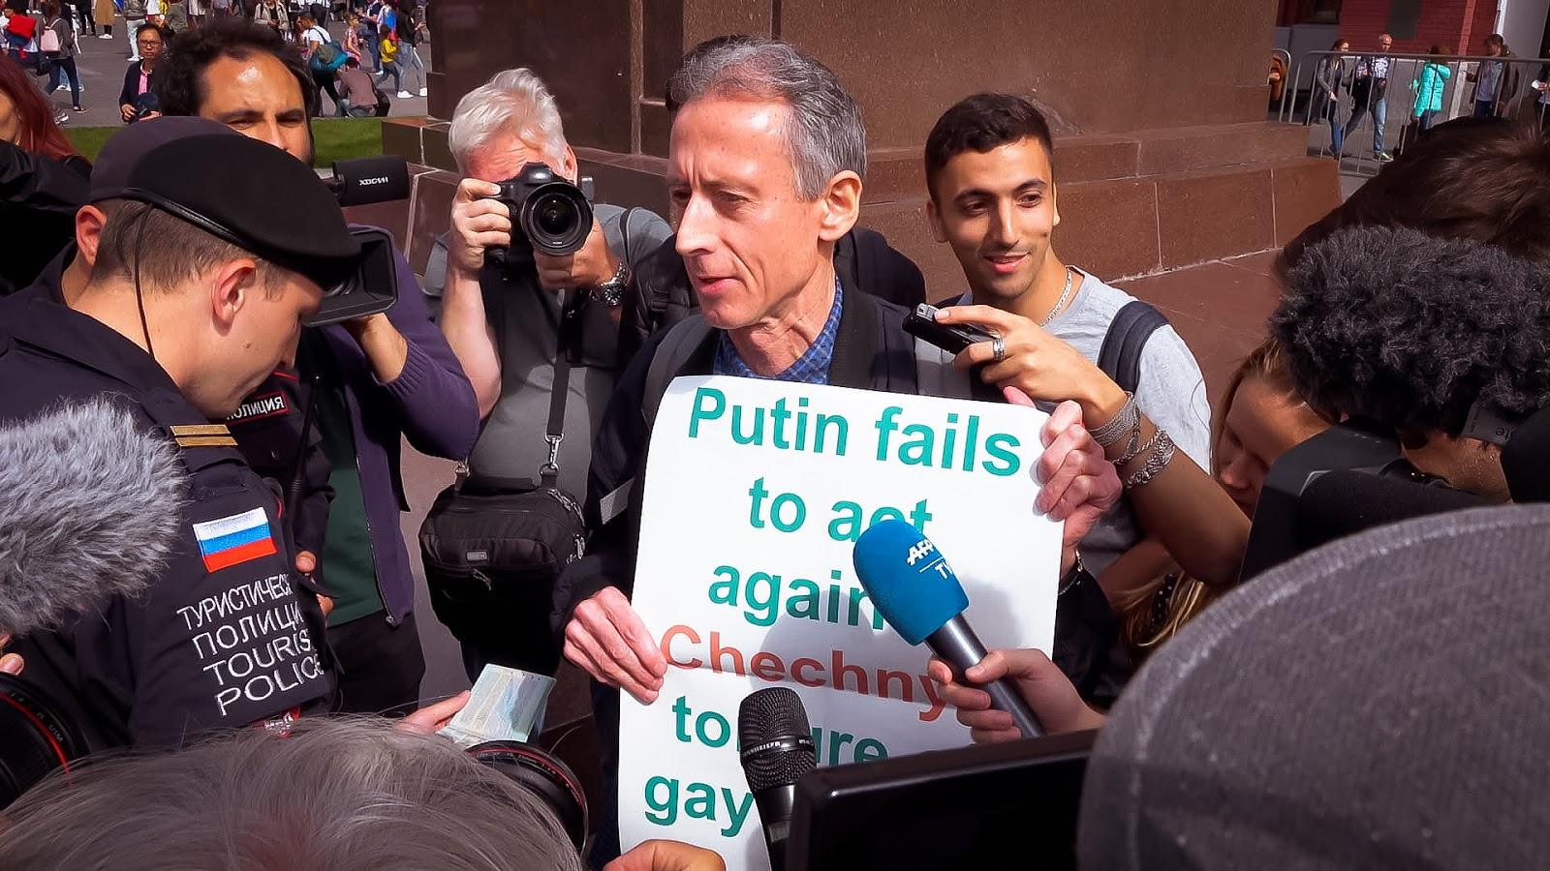
2021

SYNOPSIS

ONE LINE SYNOPSIS
The profound life story of the controversial human rights campaigner whose provocative acts of civil disobedience rocked the British establishment, revolutionised attitudes to homosexuality and exposed tyrants in the fight for equality.

SHORT SYNOPSIS
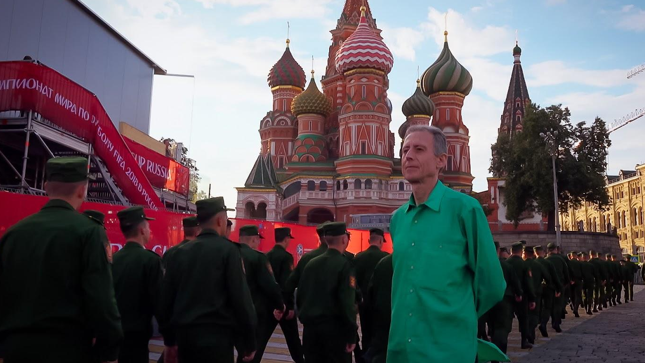
From Executive Producers Elton John and David Furnish, Hating Peter Tatchell is the powerful and inspiring true story of the controversial human rights campaigner whose provocative acts of civil disobedience rocked the British establishment, revolutionise attitudes to homosexuality and exposed world tyrants. As social attitudes change and history vindicates Peter’s stance on gay rights, his David versus Goliath battles gradually win him status as a national treasure. Featuring an amazing array of rare archive and an intimate conversation between celebrated actor Ian McKellen and Peter himself, as well as evocative interviews with the likes of former Archbishop of Canterbury George Carey, activist Angela Mason, and actor Stephen Fry, this film explores what motivates Peter Tatchell's lifelong fight for equality. It follows Peter now as he embarks on his riskiest crusade yet by seeking to disrupt the FIFA World Cup in Moscow to draw attention to the persecution of LGBT+ people in Russia and Chechnya.
FULL SYNOPSIS

This is a true story of how one man’s protest helped change society. Born into a violent, poverty-stricken, God-fearing family in the outer suburbs of Melbourne, Peter Tatchell moved to London as a young man and channelled many of his adverse childhood experiences into a lifelong fight against tyranny, inequality and injustice. Vilified by the British press and regularly bashed for his endeavours, Hating Peter Tatchell explores what has driven the controversial human rights campaigner to risk his life again and again by staging more than three thousand provocative acts of civil disobedience.
In an intimate interview with Peter, celebrated film actor and fellow gay rights activist, Ian McKellen, probes what has inspired, motivated and fuelled Peter Tatchell’s six-decade assault on the prejudices of the British establishment and his long career fighting injustices across the globe.
Peter’s journey begins in the anti-Vietnam War movement when he is just a teenager. To avoid compulsory conscription in what he believes is an unjust war, he sails from Australia to London and falls in with the Gay Liberation Front, helping to organise the UK’s first gay pride parade.
Looking to shake up the establishment, in the early 1980s Peter makes a move into the political mainstream by standing as a Labour candidate in the Bermondsey by-election. He finds himself embroiled in one of the most vicious and notoriously homophobic smear campaigns in British electoral history. When he loses the election, Peter vows to never play by the rules again. He’s tried playing by the rules. Now he’s going to break them.
Abandoning traditional politics, Peter diverts his energies into the radical non-violent gay rights direct action group OutRage! and takes the fight for equality to the very pillars of the British establishment. Using provocative stunts, wicked humour and theatrical forms of protest, OutRage! lives up to its name by confronting everyone from Prime Minister Margaret Thatcher to the Archbishop of Canterbury.
Experiencing the full wrath of the church, state and media, Peter is dubbed ‘the most hated man in Britain’. Unbowed and defiant, he ups the ante by attempting a citizen’s arrest on Zimbabwean tyrant Robert Mugabe and by shirtfronting homophobic trash-talking heavyweight boxing champion of the world Mike Tyson.
As social attitudes change and history vindicates Peter’s stance on gay rights, his David versus Goliath battles gradually win him first grudging approval and then status as a national treasure. Now Peter is embarking on his riskiest crusade yet as he seeks to stage a protest at the FIFA World Cup in Moscow to draw attention to the persecution of LGBT+ people in Russia and Chechnya. All he has to do is not get killed, bashed, imprisoned or ‘disappeared’ by Putin’s goons, the might of the Russian security state and roving gangs of Neo Nazis.
What could possibly go wrong?
From Executive Producers Elton John and David Furnish, Hating Peter Tatchell is the profound true story of one of the world’s most influential human rights activists. This film explores the motivations and consequences of Peter's direct action campaigning and the personal sacrifice that comes with this line of work, including violent attacks and threats to kill him. Told through previously unseen footage of Peter’s activism, intimate family moments, rare news headlines and interviews with the likes of actor Stephen Fry, activist Angela Mason and former Archbishop of Canterbury George Carey, this film gives a raw insight into Peter and his life’s work defending human rights.
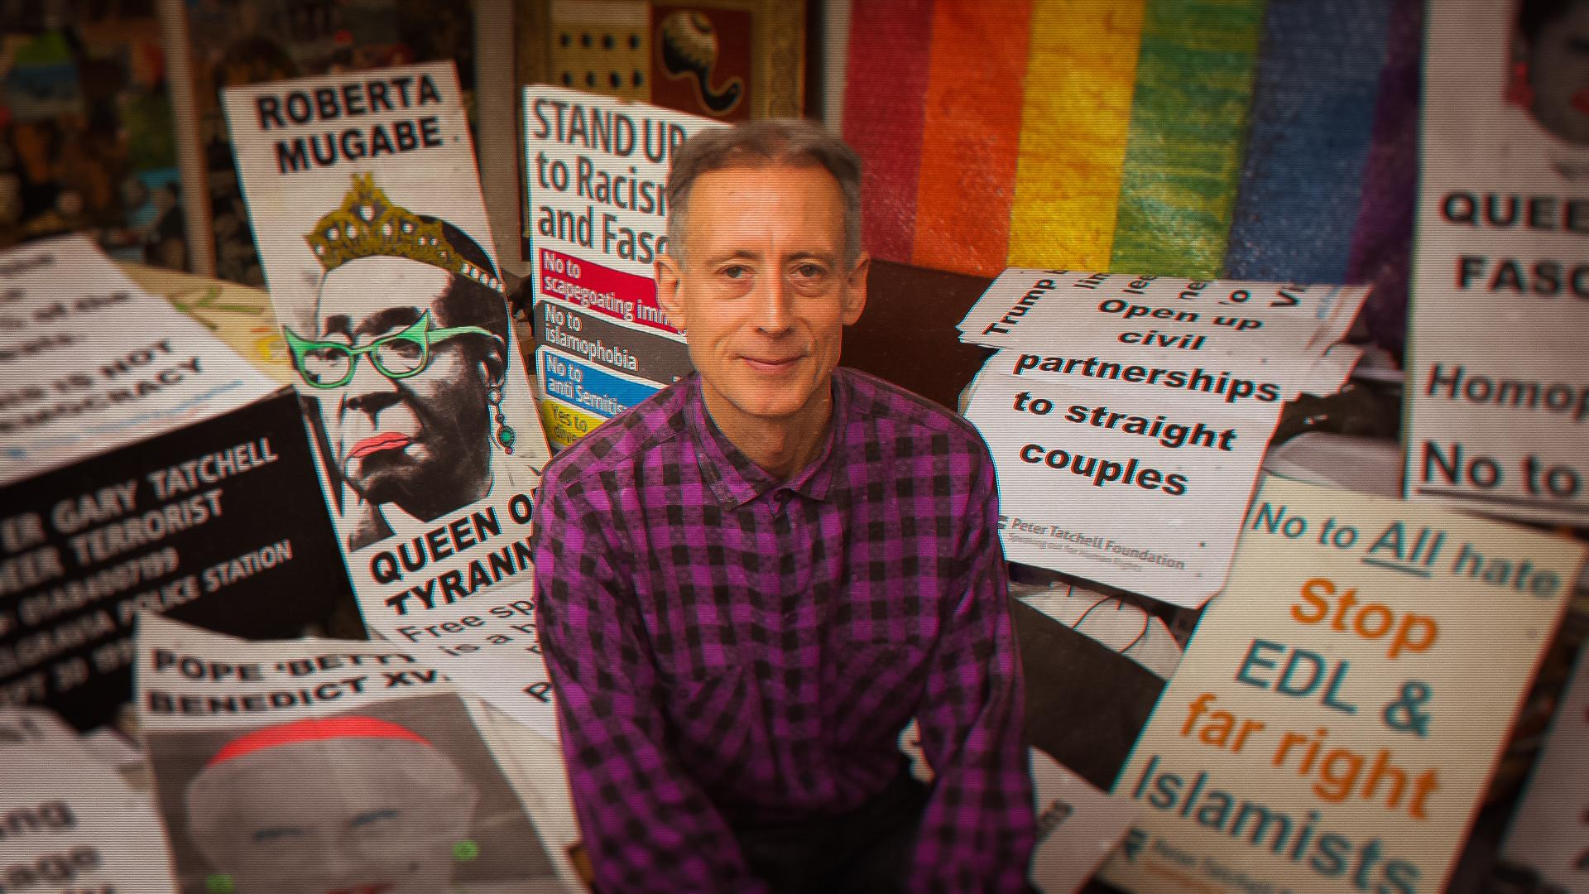
DIRECTOR’S STATEMENT

In 1999, I first met activist Peter Tatchell soon after arriving in London from Australia. I was drawn to his dedication to campaigning for human rights over such a sustained period, thirty plus years already at the time.
Yet, despite his considerable efforts fighting for equality, Peter was facing severe criticism, even from within the LGBT+ community. Shockingly this included hate mail and death threats. Throughout the time I have known Peter he went from being a public figure who the media and critics loved to hate, to a beloved national treasure - this fascinated me.
Over the past two decades, I have come to appreciate first-hand Peter’s eccentricities, his meticulous organisation and witnessed his arsenal of direct action tactics defending human rights. I admire his dedication and bravery.
In 2016, I set about making my feature directorial debut to tell Peter’s incredible story. Following three years of research, development and funding knockbacks in the UK, on the advice of a mentor, I moved back to Australia to seek finance. Soon after, Veronica Fury of WildBear Entertainment embraced my vision to document Peter’s life’s work and we were in production.
In February 2020, we were fortunate to travel to London to film our master interviews, including interviews with Stephen Fry, Ian McKellen and Peter Tatchell. We returned to Australia to edit the film one month before the COVID-19 pandemic restrictions occurred.
Throughout this lockdown period, the entire post-production team, including a dozen musicians, worked remotely from their homes scattered across the UK and Australia. Coincidentally, the Black Lives Matter campaign reignited just as we finished our film about a direct action legend. Suddenly, there seemed a deep sense of urgency to tell Peter’s story now.
Society can be unkind to those who shake up the status quo. People are afraid of change. In Peter’s case, he forces people to take a stand on human rights issues, one way or another. Sometimes facing ugly truths is confronting, even shameful, and Peter’s direct action tactics are viewed by some as a step too far. However Peter is one of the most peaceful people I have met. He uses non-violent tactics; words not weapons, to make his point.
Peter has spoken out against human rights abuses when others have stayed silent and he remains a shining example of how one person truly can make the world a better place. By following his story, this documentary ends up a ‘how-to’ guide for direct action. Hopefully able to inspire a new generation of activists to campaign for whatever they believe in. To fight injustice like Peter.
A lot of people say, “But what can I do?” Peter doesn’t question; he acts. It is these actions and this striking mindset that deserves recognition and to which this film is a testament.

PRODUCER’S STATEMENT

Hating Peter Tatchell​ is the untold story of an amazing Australian gay rights advocate that I am so proud to bring to audiences around the world. It explores what lengths Peter has gone to - and what cost he has paid - to champion his beliefs. Despite the high stakes - the personal price, the risks and the danger - it is his vocation. Peter Tatchell is the Harvey Milk of Australia and the United Kingdom.
It was a delight working with the very talented Writer & Director Christopher Amos to tell this incredibly powerful story of Peter’s life and the impact he has had on LGBT+ rights. A journey that starts with a working class Melbourne family in the 1950s, and ends up on the global stage - albeit controversially - with the likes of Margaret Thatcher, ​Queen Elizabeth II and Robert Mugabe!
Spliced together with key interviews, the film features an extensive array of news and historical archive, and covers every aspect of Peter’s life as an activist. All of this along with intimate footage Christopher filmed as he followed the dangerous one man mission Peter undertook to protest LGBT+ persecution in Russia and Chechnya at the opening day of the 2018 FIFA World Cup.
We crafted this story with a wonderful team including Story Producer Tony Jackson, Producer Lee Matthews and Editor Bergen O’Brien – along with the broader WildBear crew in Brisbane and Canberra. A very special thank you to our interviewees and participants as well, including Ian McKellen, Stephen Fry and Executive Producers Elton John, David Furnish and Charlie Parsons.
It has also been great working with Jeff Harrison and Ari Harrison at Umbrella Entertainment (ANZ) again to release the film in Australia and New Zealand. We had invaluable support from Melbourne International Film Festival Premiere Fund Executive Producer Mark Woods and the wonderful team at MIFF. As well production finance support from Screen Australia and Screen Queensland – we are grateful for their early support of the film.
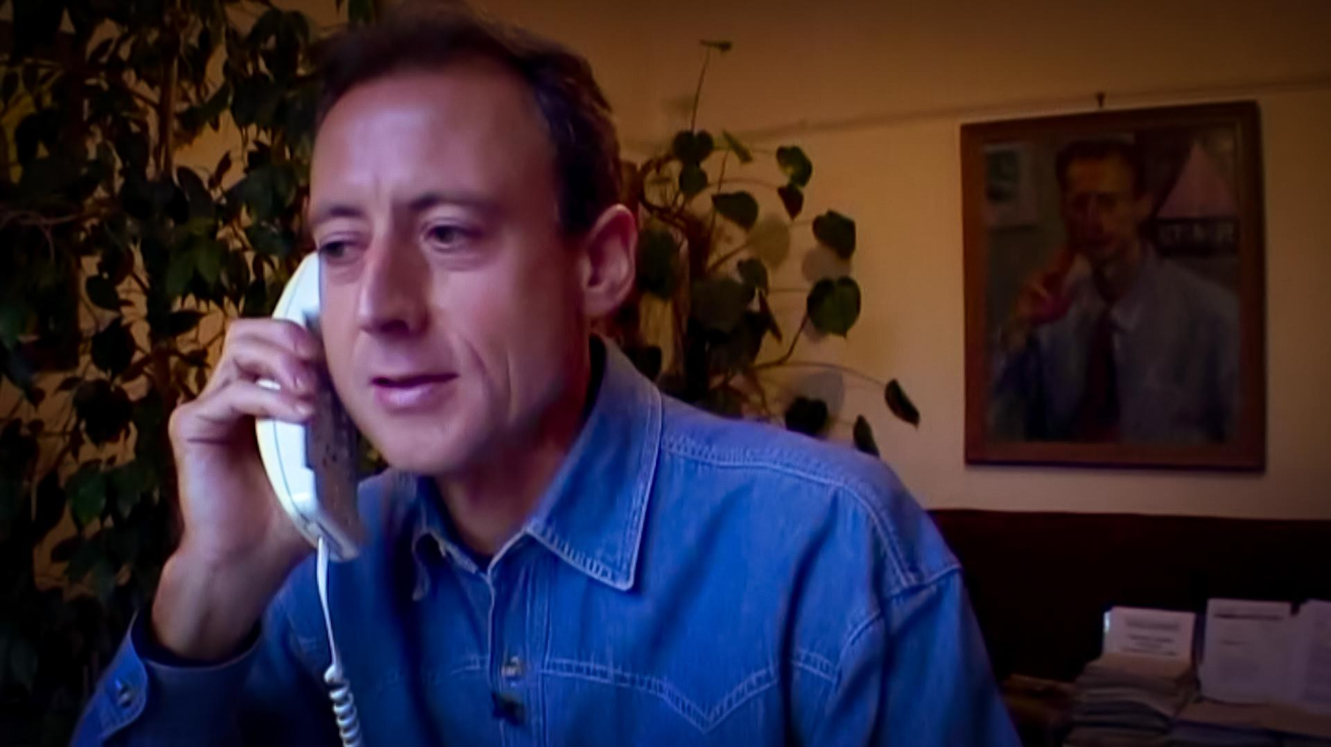
This is a timely film on human rights activism, and I hope audiences feel inspired by the work Peter has done to make the world a better place.

.

KEY CREATIVE CREDITS

Writer & Director Christopher Amos

Producers Veronica Fury
Christopher Amos
Lee Matthews

Editor Bergen O’Brien

Story Producer Tony Jackson

Camera Christopher Amos
Jim Ashcroft
Ian Chisholm

Executive Producers Elton John
David Furnish
Mark Woods
Michael Tear
Jeff Harrison
Ari Harrison
Charlie Parsons
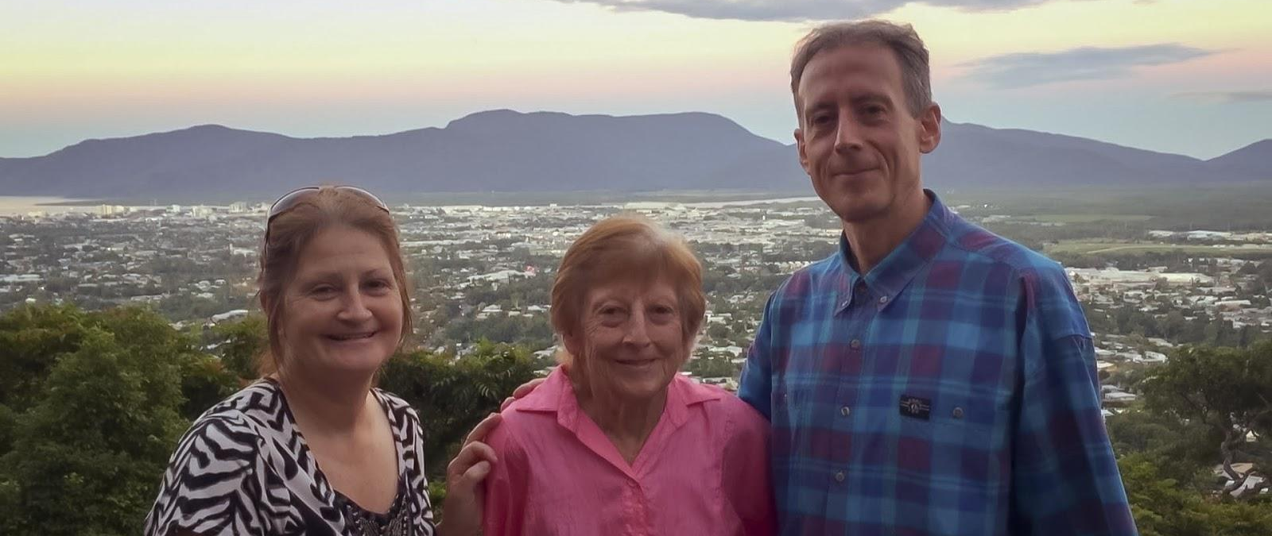

BIOGRAPHIES

CHRISTOPHER AMOS
WRITER, DIRECTOR, PRODUCER & CAMERA
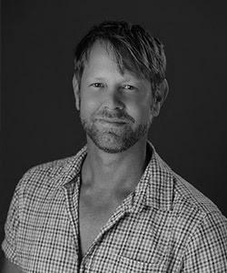
hristopher Amos is an Australian Director and Producer born in Brisbane, Australia, a resident of London for two decades from 1999 before his return home in 2019 to live in Surfers Paradise, Gold Coast.
A longtime Journalist and LGBT+ Activist, Christopher has created media content and entertainment for over two decades including his roles as Editor-in-Chief of Bent magazine in the UK and owner of iconic club Manbar in London’s trendy Soho neighbourhood.
Christopher has produced and directed independent short films, promos and documentaries. In 2015 he made his feature-length documentary debut by producing the cult film Dressed as a Girl, which premiered at Sheffield Doc/Fest.
Christopher originally graduated with a Bachelor of Arts degree in Film & Television from Queensland University of Technology and studied a Masters in Scriptwriting from the London School of Film, Media & Performance.
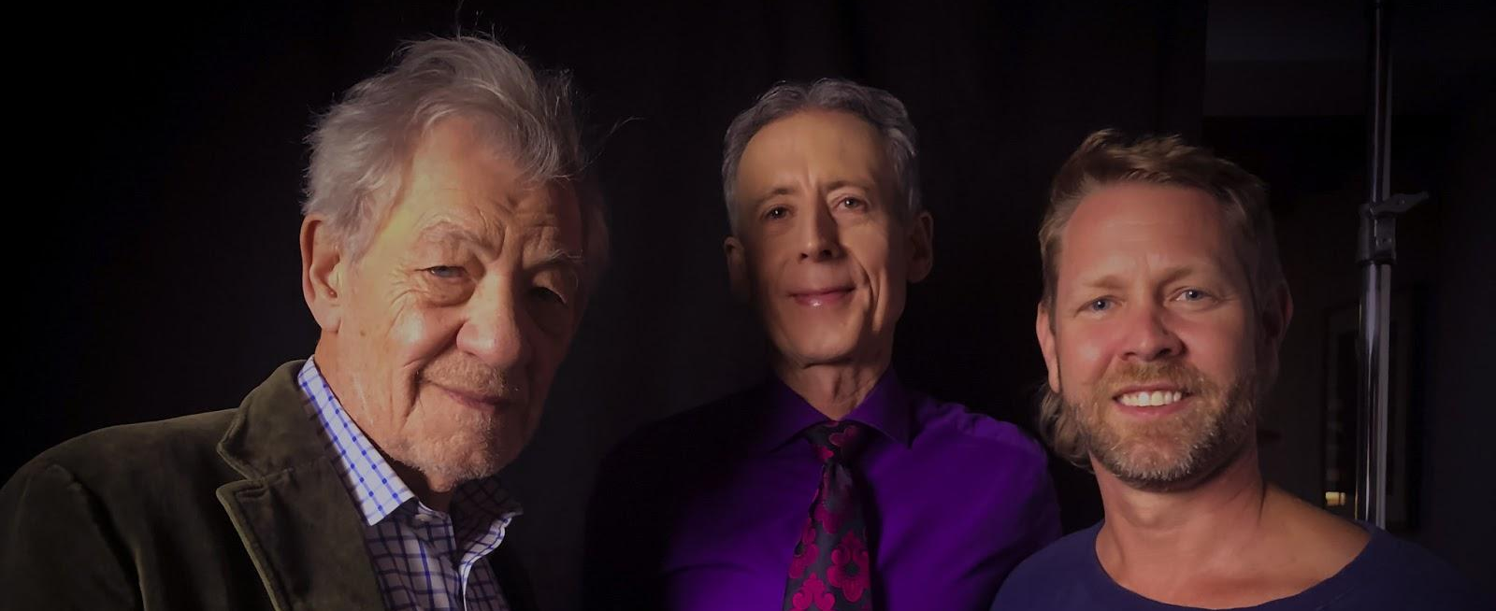
In 2021, Christopher makes his feature documentary directorial debut with Hating Peter Tatchell, following the remarkable life story of one of the world's most famous human rights activists, and featuring film stars Ian McKellen and Stephen Fry.

VERONICA FURY
PRODUCER
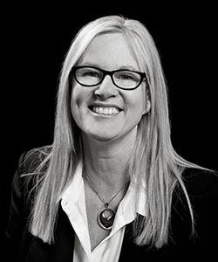
Veronica Fury is an Executive Producer and Principal of WildBear Entertainment. WildBear produces over 150 hours of factual screen content every year and has offices in Canberra, Brisbane, and Sydney.
With over 60 commissioned television and feature documentaries to her name, Veronica has worked with television broadcasters in Australia such as ABC TV, Discovery, and SBS, as well as major international broadcasters including ZDF Arte, Nat Geo, American Heroes Channel, TG4, France 5, BBC and Arte France.
Veronica has a track record of producing high profile, award-winning feature documentaries including TIFF selected Machete Maidens Unleashed! and AACTA award nominated film Curse of the Gothic Symphony. In 2015, Electric Boogaloo: The Wild, Untold Story of Cannon Films premiered at TIFF and London
Film Festival before being released by Warner Brothers. Her most recent feature documentaries include Iron Fists and Kung-Fu Kicks which was commissioned by Netflix, premiered at MIFF and was selected for Sitges, Fantastic Fest and L'Étrange Festival and biography Brock: Over The Top for Universal Pictures and ABC TV.
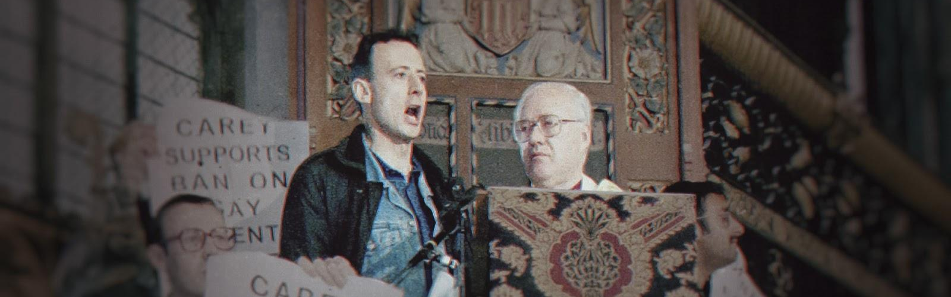
Recently Veronica produced popular series Aussie Mega Mechanics and Demolition Down Under for Network 10 and Discovery. She has also produced the ob-doc series commissioned by BBC Scotland, Scottish Vets Down Under which has also been picked up locally by the ABC.
SELECT PRODUCTION BIOGRAPHIES

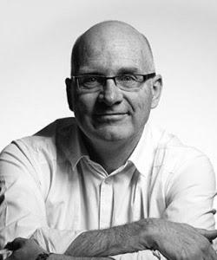
MICHAEL TEAR
PRODUCER
Michael Tear has extensive experience as a Producer and Executive Producer of television, TVC and government and corporate communications. Michael is currently the President of Screen Producers Association Australia and sits on various boards nationwide. His notable projects, both one-offs and series includes The Story of Australia, New Zealand From Above, The Digger (Gold Dolphin winner at the Cannes Film and Television Awards), Michael was also an Executive Producer on the feature film The Babadook (Official Selection at Sundance Film Festival).

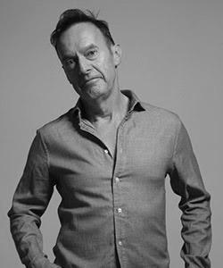
CHARLIE PARSONS
EXECUTIVE PRODUCER

Charlie Parsons is an acclaimed TV and theatre Producer from the UK. Widely regarded as the father of reality TV for his work creating global TV format, Survivor. Charlie is also the brains behind many UK TV shows including The Big Breakfast, Gaytime TV (the first regular LGBT+ programme on the BBC) and The Word. His first Broadway show Girl from the North Country, based on songs by Bob Dylan, recently opened to amazing reviews. Parsons regularly mentors and supports creative people and businesses.

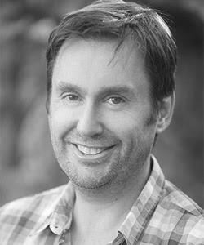
LEE MATTHEWS
PRODUCER
Charlie Parsons is an acclaimed TV and theatre Producer from the UK. Widely regarded as the father of reality TV for his work creating global TV format, Survivor. Charlie is also the brains behind many UK TV shows including The Big Breakfast, Gaytime TV (the first regular LGBT+ programme on the BBC) and The Word. His first Broadway show Girl from the North Country, based on songs by Bob Dylan, recently opened to amazing reviews. Parsons regularly mentors and supports creative people and businesses.

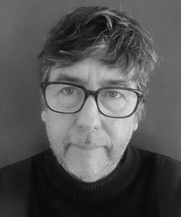
TONY JACKSON
STORY PRODUCER
Tony Jackson has spent more than thirty years producing/directing television and documentaries, earning his first stripes at the BBC before becoming Head of Television at Lonely Planet. Tony has worked with international broadcasters and screen funding bodies in North America, Europe, the Middle East, China and Australia. He has been twice nominated for a Walkley Award for Excellence in Journalism and is the winner of a Screen Producers Australia Award.

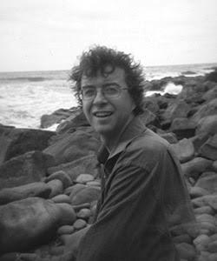
BERGEN O’BRIEN
EDITOR
Bergen O'Brien is an accomplished and award-winning Australian documentary Editor. His recent documentaries include Aftermath: Beyond Black Saturday, The Song Keepers, PACmen, Ballroom Rules and Black As.

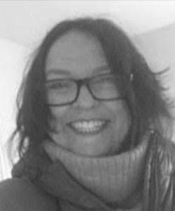
MAGS SCHOLES
ASSOCIATE PRODUCER
& PRODUCTINO MANAGER

Mags Scholes has over 25 years film and TV experience in both production and previously sound recording. She has production credits for hundreds of hours of broadcast and theatrical content including for HBO, Discovery, BBC, SBS, and in the UK, Channel 5, MTV and Channel 4 among others. Her recent feature documentary Great Green Wall screened at the 2019 Venice Film Festival, EPed by Oscar Nominated Director Fernando Meirelles (City of God, The Constant Gardener).

INTERVIEWEES

Adrian Arbib Photojournalist
Angela Mason Civil Servant and Activist
George Carey Former Archbishop of Canterbury
Heather Kniese Peter Tatchell’s Sister
Helen Hill Academic and Activist
Chris Smith Politician
Mardi Nitscke Peter Tatchell’s Mother
Peter Tatchell Human Rights Activist
Stephen Fry Actor, Comedian & Writer
Tom Robinson Singer and LGBT+ Activist

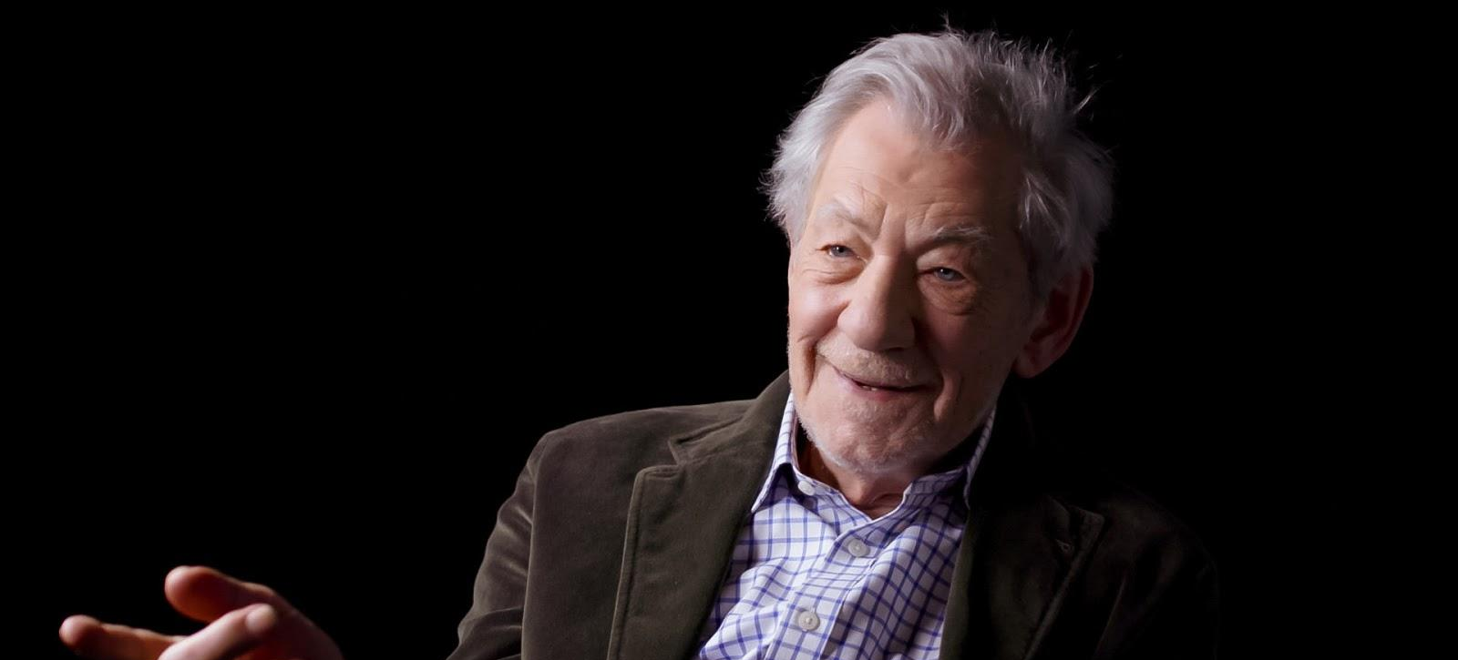

END CREDITS

Card 1
Writer & Director
CHRISTOPHER AMOS

Card 2
Producers
VERONICA FURY
CHRISTOPHER AMOS
LEE MATTHEWS

Card 3
Editor
BERGEN O’BRIEN

Card 4
Story Producer
TONY JACKSON

Card 5
Camera
CHRISTOPHER AMOS
JIM ASHCROFT
IAN CHISHOLM

Card 6
Executive Producers
ELTON JOHN & DAVID FURNISH

Card 7
CHARLIE PARSONS
MARK WOODS
MICHAEL TEAR
JEFF HARRISON
ARI HARRISON

Card 8
Associate Producer
MAGS SCHOLES

End Credits - Roll
By watching this film legally you have supported numerous jobs of creatives, distributors and crew listed below.

Archive Producer MOLLY O’CONNOR

In Conversation PETER TATCHELL
IAN MCKELLEN

Interviewees ADRIAN ARBIB
ANGELA MASON
GEORGE CAREY
HEATHER KNIESE
HELEN HILL
LORD CHRIS SMITH
MARDI NITSCKE
STEPHEN FRY
TOM ROBINSON

Story Consultant DAVID COLLINS

Music Supervisor GARY SEEGER

Production Manager MAGS SCHOLES

Production Coordinators SHANNEN TUNNICLIFFE
RUBY SCHMIDT

Additional Camera JOEL RYDER
MAX BARBER

Camera Assistant VALENTIN LE GLAUNEC

Sound Recordist ALI PARES

Stills Photographer ALI PARES

Hair and Makeup Artist ESZTER HERCZSK

On Set Production Assistant OLIVE FAURE

End Credits Continued.../

Post Production by WildBear Entertainment

Head of Post Production MATTHEW NIGHTINGALE
Post Production Supervisor WILLIAM WARD
Online Editor TAN TRAN
Colourist ANNICA MOTT
Graphics Manager ZOE WHITTAKER
Titles & Graphics PRAJDNIK AWASTHI
Sound Editors BRENDON KIRK
MYLES WRIGLEY

Re-recording Mixer THOM KELLAR
Mix Facility FOLKLORE SOUND

Post Production Script THE LAST DRAFT

For WildBear Entertainment

WildBear Entertainment Principals VERONICA FURY
BETTINA DALTON
MICHAEL TEAR
SERGE OU

General Manager HARRIET PIKE
Head of Production HOLLY TRUEMAN
Managing Director ALAN ERSON

Financial Controller CAROLINE NICHOLS
Head of Production Finance MIRANDA FELTON
Production Accountant VANESSA HEPBURN

Business Affairs CLARE HEDLEY
PAUL WU
Development Producer JENINE OLLIVER
Supervising Producer STEPHEN WALLER

End Credits Continued.../

Development Assistant MIRANDA NELSON
Executive Assistant REBECCA SHAW
ICT Manager PETER TAYLOR

Legal Advisors MARSHALLS+DENT+WILMOTH LAWYERS
ODILLA O’BOYLE
MARCO ANGELE

Travel Agent TAG GROUP
Studio 01ZERO-ONE
Auditor CHRISTOPHER COOTE & CO
Insurance Broker ARTHUR J GALLAGHER
Completion Guarantee provided through FILM FINANCES
Transcribers BRITTANY GIRVEN
DOMINIC DEUTSCHER
KASSANDRA PATRONO
THOMAS COADE

German Translations SEBASTIAN GOLDHORN
Russian Translations VIC ASGAR

End Credits Continued.../
Archival Footage Courtesy of

10X MEDIA GROUP/CHANNEL 4
10X MEDIA GROUP/REUTERS
ABC NEWS VIDEOSOURCE VIA GETTY IMAGES
ADRIAN ARBIB
AFPTV VIA GETTY IMAGES
ANTI WAR DEMONSTRATION FOOTAGE “BEGINNINGS 1971”
(C) CRADLE MOUNTAIN FILM PRODUCTIONS PTY LTD
AP ARCHIVE
AUSTRALIAN BROADCASTING CORPORATION LIBRARY SALES
BBC
BBC MOTION GALLERY EDITORIAL/BBC ARCHIVE VIA GETTY IMAGES
BBC MOTION GALLERY EDITORIAL/BBC NEWS VIA GETTY IMAGES
BBC OFFLINE MOTION GALLERY VIA GETTY IMAGES
BFI UK
BRITISH MOVIETONE
CAMPAIGN FOR HOMOSEXUAL EQUALITY
CONSERVATIVE PARTY UK
CONTENT MINT
EURONEWS
FIFA FOOTAGE COURTESY OF FIFA. ALL RIGHTS RESERVED. ©FIFA
FOOTAGE SUPPLIED BY THE NATIONAL FILM AND SOUND ARCHIVE
OF AUSTRALIA'S FILM AUSTRALIA COLLECTION
FREMANTLE AUSTRALIA
GAVIN HELLIER VIA GETTY IMAGES
HEARST NEWSREEL VIA GETTY IMAGES
ISLAMIC EDUCATION AND RESEARCH ACADEMY
ITN ARCHIVE LIMITED VIA GETTY IMAGES
ITN VIA GETTY IMAGES
ITV ARCHIVE
End Credits Continued.../
JOHN SHANE
KINOLIBRARY
KOUGLOFF VIA GETTY IMAGES
MAX BARBER
MELBOURNE MAY DAY COMMITTEE
MERVYN MCKAY
NEUMA CHURCH
NINE NETWORK AUSTRALIA
OPEN MEDIA
OPEN MIKE PRODUCTIONS
PA
POOL
PROGRESS.FILM
RANDOLFE WICKER
ROBERT KILROY-SILK
SCRIPPS - WPIX, NEW YORK VIA GETTY IMAGES
SKY NEWS
SKY NEWS/FILM IMAGE PARTNER VIA GETTY IMAGES
SNTV
STEPHEN RUTSKY
STV
THE ATTITUDE AWARDS AND ATTITUDE MAGAZINE
THE FOOTAGE COMPANY
THE RANK ORGANISATION
“THE SECRET POLICEMAN’S BALL (1979)”
EXTRACT COURTESY OF AND © ‘AMNESTY INTERNATIONAL’
VLADIMIR IVANOV
WORKING CLASS HISTORY: THE STONEWALL RIOTS AND PRIDE AT 50
WTN
End Credits Continued.../

Archival Stills Courtesy of

© DEUTSCHES HISTORISCHES MUSEUM
© M. SVANDERLIK FOR PROJECT
LONDONERS AT HOME: THE WAY WE LIVE NOW
© TELEGRAPH MEDIA GROUP LIMITED 1995
ADRIAN ARBIB
ALEXANDER TITORENKO/AFP VIA GETTY IMAGES
ANTHONY DEVLIN - PA IMAGES VIA GETTY IMAGES
AP PHOTO
AP PHOTO/MAX NASH
BILL SHORT
ENTERTAINMENT PICTURES / ALAMY STOCK PHOTO
GARETH CATTERMOLE VIA GETTY IMAGES
GAY MEN'S PRESS
JAMIE GARDINER
LANDESARCHIV BERLIN
LONDON SCHOOL OF ECONOMICS LIBRARY
MARGARET GLOVER
MOUNT WAVERLEY SECONDARY COLLEGE
STATE OF VICTORIA 2020. WITH PERMISSION GRANTED
FROM THE DEPARTMENT OF EDUCATION AND TRAINING
NEW STATESMAN
NEW YORK DAILY NEWS ARCHIVE VIA GETTY IMAGES
NICK POTTS - PA IMAGES VIA GETTY IMAGES
PETER BOLL
POLA DAMONTE VIA GETTY IMAGES
POLLY BORLAND VIA GETTY IMAGES
POSTER, END VIETNAM WAR, 1970
COURTESY OF CITY OF MELBOURNE COLLECTION
End Credits Continued.../

REACH PUBLISHING SERVICES LTD
SOLO SYNDICATION DMG MEDIA
SOUTH LONDON PRESS
STEPHEN MAYES
THE AGE
THE SUN
THE SUN / NEWS LICENSING
TRIBUNE MAGAZINE
WORKERS WORLD
WORLD FEDERATION OF DEMOCRATIC YOUTH

The producers have made every effort to contact and locate the owners of copyright materials appearing in this motion picture. Should anyone become aware that material has been used without permission, please contact the producer via wildbear.tv/contact

Music

Music composed, performed and produced by ANDREW BARNABAS & PAUL ARNOLD
Strings performed by THE STEVE BINGHAM PLAYERS
Scores prepared by ROWAN ALFRED
Violins STEVE BINGHAM
PHILIP AIRD
MARINA GILLAM
FIONA ROBERTSON
Violas BRENDA STEWART
STEVE BINGHAM
Cellos JAMES HALSEY
JOSHUA LYNCH
Double Bass CHRISTIAN GELDSETZER

End Credits Continued.../

A Little Respect (2009 Remaster)
Performed by Erasure
Courtesy of Warner Records
By arrangement with Warner Music Group Film & TV Licensing
(P) 2009 Mute Records Ltd., a BMG Company
Licensed Courtesy of BMG Rights Management (Australia) Pty Ltd
Written by Andy Bell and Vince Clarke
© Musical Moments Ltd. (UK) and SM Publishing UK Limited
Licenced by Sony/ATV Music Publishing (Australia) Pty Ltd

A Little Respect (instrumental)
Performed by Jennifer Msumba
Written by Andy Bell and Vince Clarke
© Musical Moments Ltd. (UK) and SM Publishing UK Limited
Licenced by Sony/ATV Music Publishing (Australia) Pty Ltd

The Ballad of Accounting
Performed by Ewan MacColl and Peggy Seeger
from the recording entitled Folkways Record of Contemporary
Songs, FW08736, courtesy of Smithsonian Folkways Recordings
(p) (c) 1973. Used by permission.
Written by Ewan MacColl Published by Native Tongue Music
Publishing Pty Ltd obo Concord Music Publishing LLC

End Credits Continued.../

Glad To Be Gay
Performed by Tom Robinson
from The Secret Policeman’s Ball (1979) extract
Courtesy of © Amnesty International
Written by Robinson (C) Konkwest Music Limited Licensed
Courtesy of BMG Rights Management (Australia) Pty Ltd

Believe
Performed by Elton John
Under exclusive license from Mercury Records Limited
Licensed courtesy of Universal Music Australia Pty Ltd.
Written by: John/Taupin
WAB Publishing Ltd., Rouge Booze. Inc.
Administered by: Universal Music Publishing Pty Ltd

Additional Music
Audio Network

End Credits Continued.../
With Special Thanks
GRAEME MASON
ALYSSA ORVIS

KYLIE MUNNICH
JO DILLON
KASIE MOORE
ANDREA COYLE
MARK DUNNING

EDDIE COUPE
JESSICA BREWSTER
CAROLINE VERGE

PAULA JENSEN
RUSSELL ALLAN

ANDREW CAREY
JO CROCKER
LOUISE HARDY
ZOE MILLER

ADAM FREEMAN
ADAM HILL
ADRIAN TIPPETTS
ANDRÉ SINGER
ANDY BELL
BORIS BROVTSYN
BRUCE EVANS
CAROL UNWIN
CELINA DUNLOP
CHARLES HILL
CHRIS SANDLAND
CHRISTINE CRAWFORD
COLIN RIVHARD ROTHBART
DANIEL LYNCH
DANIEL SPITERI
DAVID AIRD
DAVID SHENTON
DAVID TOUBE
DUNCAN CRAIG
EDWARD O’NEIL
ELTON JOHN

End Credits Continued.../
FENTON BAILEY
FIGS JACKMAN
FRANCES NEWELL
FREDERICK MALONE
GARRY HICKS
GASTON DESIDERIO
GEOFF HARDY
GREGORY NASH
HARRY VAN MOORST
IVAN JACKSON
JAMES LEDWARD
JEREMY N. HOOKE
JOEL CHURCHER
JOHAN CLOETE
JOHN BELLAMY
JOYCE STRACHAN
KEITH COLLINS
KENNY MUNNELLY
LEIGH BISSETT
MARC KERSHAW
MARILYN CROSSLEY
MAT SNEAD
MICHAEL EGGERT
MICHAEL FURNISS
MICHAEL PEACOCK
MIKE DOWN
NEAL CAVALIER-SMITH
NEIL LAIDLAW

End Credits Continued.../
NICK RANDELL
NOEL DEBIEN
PATRICK WALSH
PAUL RATCLIFFE
PETER MACLEOD-MILLER
PETER RAUSCH
PETER TATCHELL FOUNDATION
RENATO ALVES APARECIDO
RICHARD KIRKER
RODNEY CROOME
RUPERT EVERETT
SIDDHI JOSHI
SIMON RUTH
STEPHEN GRIFFITHS
THE HONOURABLE MICHAEL KIRBY AC CMG
THORGE LORENZEN
TONY MCNULTY
TWYSDEN MOORE
VIRGINIA AMOS

Thanks to
AMY ASHENDEN, ASK KOTAK, ATTITUDE MAGAZINE, BOYZ MAGAZINE, CASPER AMOS, CHRIS COLMAN, DEBORAH LANE-WINTER, ECA EPS, EVENING STANDARD, FELIX AMOS, FRONT RUNNER MAGAZINE, GAY TIMES, GILL BUTLER, HEIDI WHEELER, IMKE ELSTNER, JACKIE AMOS, JEREMY INGLIS, JOCHEN HICK, JOHN WITIW, KIRSTEN SPRY,
KLETUS CLIFF JOANNOU, LUKA ŠTEMBERGER, MATHEW WARD, OUMANI BROWNE, PLEASUREDROME, QX MAGAZINE, SERGI DOLADÉ, SHARON BARBOUR, STEFAN DICKERS, STEPHEN VOWLES, TANYA LOOS

End Credits Continued.../
Thanks to Our Kickstarter Crowdfunders
Associate Producer
NICK WATKISS
ADRIAN REED, ADRIAN SMITH, ADRIENNE LINTZGY, ALAN BECK, ALAN NEWBURY, ALASTAIR IRONSIDE, ALEJANDRO OLMEDO DOMINGUEZ, ALEX BURTON-KEEBLE, ALISTAIR DAVID, ANASTASIA KYRIA, ANDREW & DITA HUMPHRIES, ANDREW GRAY, ANDREW SMITH, ANDY WHITE, ANGELA LYNCH, ANNETTE MILVERTON, ANTHONY BAKER, ANTHONY COX, ANTHONY O'CONNELL, ARASH 'ASH' HESAMI, ARISTOTELES BARCELOS NETO, BARRY BOFFY, BEN FORDER, BEN WALTERS, BERNARD MICHAEL, BEVERLEY TROUNCE, BORIS KHMELNITSKIY, BRUCE AMOS, CAROLINE WEBB, CELIA KITZINGER, CHLOE ROSE, CHRIS OWEN, CLAIRE DIKECOGLU, COLIN TURNBULL, CYRUS GILBERT-ROLFE, DAN CHEETHAM, DANIEL BRETT, DANIEL JOSEPH RUBIN, DARREN LOVELL, DAVE BURKE, DAVID BIRD, DAVID CARTER, DAVID GWINNUTT, DAVID HOYLE, DAVID LLOYD, DAVID MASON, DAVID OPPEDISANO, DAVID STICKLEY, DEAN HAMER, DOMINIC DAVIES, ELLIOT RICHARDS, ERIC BONHARME, ERICA NEUSTADT, FABRICE TASENDO, FIONA OUTRAM, FLORENT LETURMY, GABRIEL VOGT, GARETH PARKINSON, GARY BIGGS, GARY WILLMOTT, GEORGE GOODFELLOW, GEORGE TAYLOR, GEORGIE HULME, GERALDINE BATHE, GRAHAM SUGARLUMP POWER, GRANT KEIR, GUY KERVELLA, HEATHER BROWN, HELEN TROILO, HOLESTAR, HUGO MORRIS, IAN BONHOTE, IGOR MUSULIN, INGRID COPE, JACOB DIJKSTRA, JAMES VAUGHAN, JANE ANGEL, JANE CALLAGHAN, JANI PHILLIPS, JAYNE, JEAN T OSBORNE, JEFF BUTTON, JEFF CARL, JEREMY GILBERT-ROLFE, JESSICA HARDING, JETT NYX, JIMMY ONE EYE, JOANNA BURNIP, JOHN JEFFERY, JOHN KELLY, JOHN MARTIN GREGORY, JOHN SHELDON, JONATHAN BOWEN, JONATHAN DIESCH, JOOST MISELL, JORDAN MCKENZIE, JOYCE HOWARTH, JULIO ROEL, JUSTIN WIEBE, KATE RUTHERFORD, KATE WILDBLOOD, KATHERINE HEWITT, KERRIE GREEN, KITTYKAT, KYLE CLUETT, LAURA FEREJOHN, LAUREN HASSAN-LESLIE, LEANDER D'ARCY, LESLEY HAYWOOD, LINA LIU, LOUISE ORTON, LUKE MEREDITH, LYNSEY GREENMANN, MANDY TUCKER, MARCOS 'QBOY' BRITO, MARCOS OLEGARIO, MARCUS ALEXANDER, MARCUS BOSTRÖM, MARCUS JAMES, MARIA RODRIGUEZ, MARIANO ROBLES, MARILYN EYRE-MORGAN, MARINA CANTACUZINO, MARIO GRIMALDI, MARK BAILEY, MARK BITHELL, MARK WILSON, MARTIN BROWN, MARTINE LYONS, MARY LAW, MATTHEW MAHMOOD-OGSTON, MATTHEW RUTH, MATTHEW TORESEN, MATTHEW WEBB, MEGATOPIA FILMS, MICHAEL BUTLER, MICHAEL GIBBS, MICHAEL STYLIANOU, MICHAEL T HALL, MICHALL VINCE, MURDOCH MORRISON, NAT HOLTHAM, NEIL BABBAGE, NEKTARIOS LIOLIOS, NICK MOORE, NICK TENNEAR, NICOLA HARK, OLIVIER STOCKMAN FOR SANDS FILMS, OLLIE HAWKINS, OS DA SILVA, OSCAR G WARD, OWLBEAR, PATRICK MCCANN, PAUL WADY, PAUL WHEATLEY, PAUL WILLAMS, PETER WILCOCK, PHILIP ALEXANDER, PHILLIP M RANDALL, PIERRE PARNIS, PLINY SOOCOORMANEE, RACHEL BIRD, RAE JONES, RAFFAELE CATALANO, RAGNA HOFFMANN, RAINBOW FILM FESTIVAL, RAVI PERSAUD, RAY VINCENT, REBECCA MINTON, RENATA M, RICHARD BEAVEN, RICHARD COOK, RICK CAVERS, ROB SIMMONS, ROBERT AMIES, ROBERT BURTON, ROLAND SAUNDERS, RUSSELL DURNELL, RYAN NASON, SAL HAMPSON, SALLY HINCH, SARAH CHOONARA, SARAH SKANSING, SASHA DEFAUX, SB, SEAN PERT, SEBASTIAN SANDYS, SETTIMIO FIORENZO PALERMO, SHANTI BURN, SHARON DUGGAL, SHEILA TAYLOR, SIMON JACOBS, STEPHEN JONES, STEVEN LINDSAY, STUART ROUND, SUE TILLEY, SUE WILKINSON, THOMAS FECHTNER, TOBIAS PRISTON, TOM JONES, TOM WHELEHAN, VERITY VENTER, WILL ALLAWAY, ZSOLTI SZABÓ
www.tatchellmovie.com Twitter @tatchellmovie Facebook @tatchellmovie
End Credits Continued.../

SIXTH LAST CARD
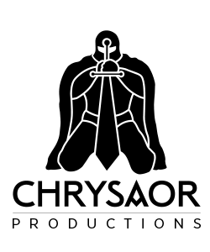

FIFTH LAST CARD
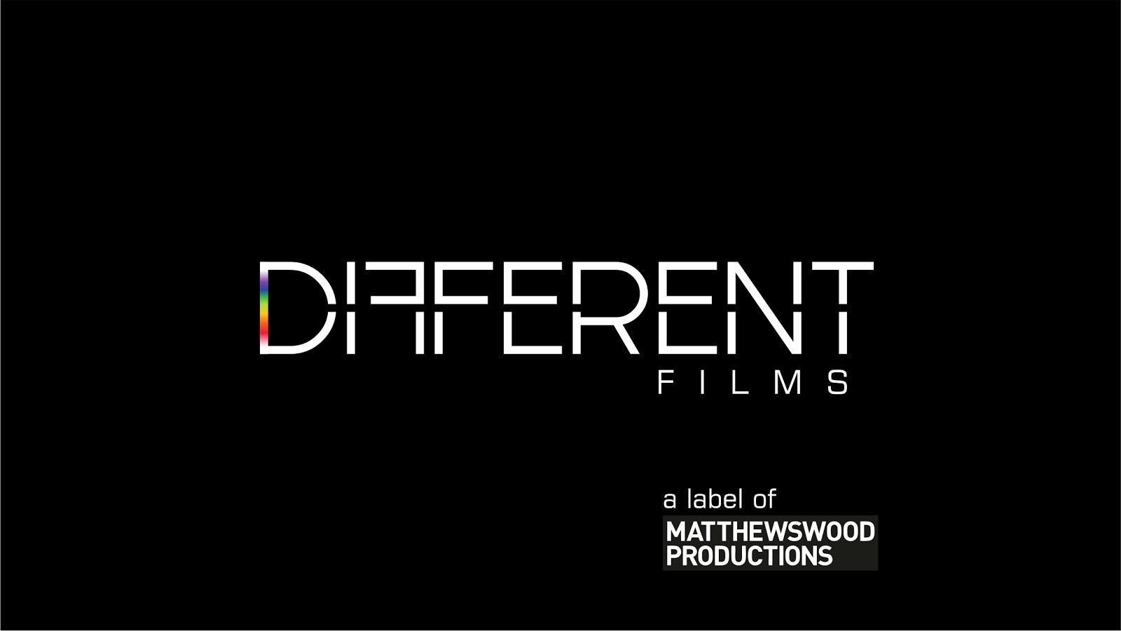

FOURTH LAST CARD

End Credits Continued.../
THIRD LAST CARD
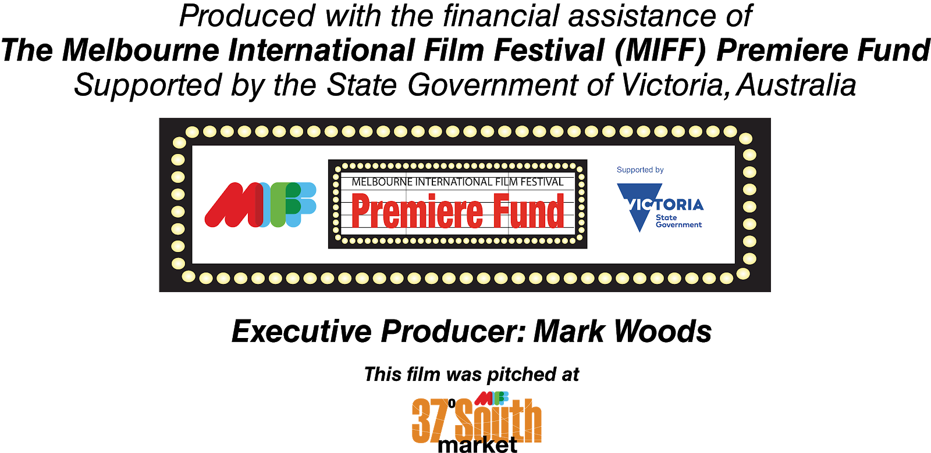

SECOND LAST CARD
PRODUCED WITH INVESTMENT FROM
LAST CARD
PRINCIPAL PRODUCTION FUNDING FROM

© 2020 WildBear Entertainment Pty Ltd, Filmfest Limited and Content Mint
ISAN: 0000-0005-B0E9-0000-3-0000-0000-S
END

